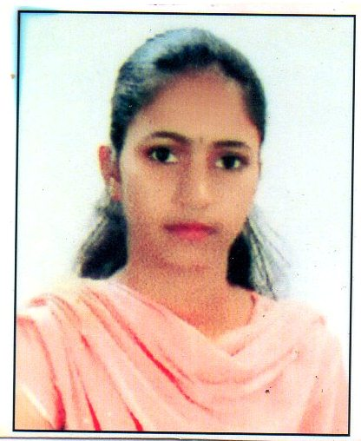
RESUME
VIDYASHREE.P
D/O PRAKASH
THALAKUPPE (V),
SHANUMANGALA (P), BIDADI (H),
RAMANAGARA (T) & (D),
PINCODE : 562109.
Mob : 9741111265.
E-mail ID : vidyavid3653@gmail.com

Objective:

Seeking a challenging position with a fast growing company where I can contribute to the growth of the organization as well as my professional career and to work in a team of dedicated and committed individuals who respect the way other works and help them work to their best potential.

Educational Qualification :
Qualification | Institute/  Board | Year of  Passing | Percentage
M.B.A | RAJARAJESWARI COLLEGE OF ENGG. RAMOHALLI BANGALORE | 2018 | PURSUING
B.B.M | JNANAVIKAS INSTITUTE OF MANAGEMENT STUDIES & COMMERCE BIDADI | 2016 | 69.88%
P.U.C | SRI BASAVESHWARA SWAMY COMPOSITE P.U COLLEGE BIDADI | 2013 | 83.83%
S.S.L.C | SRI CHOKKALINGA VIDYALAYA HEJJALA BIDADI | 2011 | 74.88%

Computer Skills :

- Basic Computer & Tally ERP 9.

Strengths :
- Self-motivated and ready to tackle any challenge
- Having excellent communication writing skills
- Having good communication
- Leadership quality

Work Experience :

- FRESHER.

Personal Details :

Name : VIDYASHREE.P

Father Name : PRAKASH

Mother Name : Venkatalakshmi

Date of Birth : 10/07/1995

Gender : Female

Marital Status : Unmarried

Permanent Address : VIDYASHREE.P D/O PRAKASH
THALAKUPPE (V), SHANUMANGALA (P), BIDADI (H),
RAMANAGARA (T) & (D), PINCODE : 562109.

Nationality : Indian

Religion : Hindu

Languages known :
Languages | Read | Write | Speak
Kannada
English

Hobbies : Reading News Paper & Listening Music.

DECLARATION :

I hereby declare that the above given information is true to the best of my Knowledge & Belief.

Date : Yours faithfully
Place:

(VIDYASHREE.P)

